(Approx. 612 words)

Loocid anti-fog wipes for glasses
While wearing a PPE mask, keep your glasses fog-free when you cannot carry a Rainx bottle
By John Krout, Writer/Presenter, Potomac Area Technology and Computer Society
www.patacs.org
krout75 (at) yahoo.com

A few months ago I published an article about my use of the commercial RainX product as a way to minimize fogging of glasses when wearing a PPE mask.

There is at least one situation, airplane flights, where the mask use can last hours and no bottles of fluid can be brought aboard by passengers.

More commonly, if you forget to treat your glasses with RainX before leaving home, having an alternative in the car would be useful.

My daughter, who wears glasses, has traveled two times to the DC area from her home in Georgia during September and November 2020. She has bought tickets for a third trip in December 2020. She visits not only her immediate family but also her in-laws in Northern Virginia, along with her 16-month-old son.

So what can be done?
I found an answer on Amazon. Several firms sell individually packaged anti-fog wipes. I tried one brand that was especially highly rated. The brand is Loocid, spelled with two-letter Os, and the wipes are not what I would call inexpensive. The price ranges from 45 cents to 60 cents per wipe, depending on how many are purchased.

You can see the 30packet box of Loocid packets in Illustration 1. Although the actual label depicts the two Os as a pair of glasses, you can find the product by using the name Loocid in the Amazon search field.
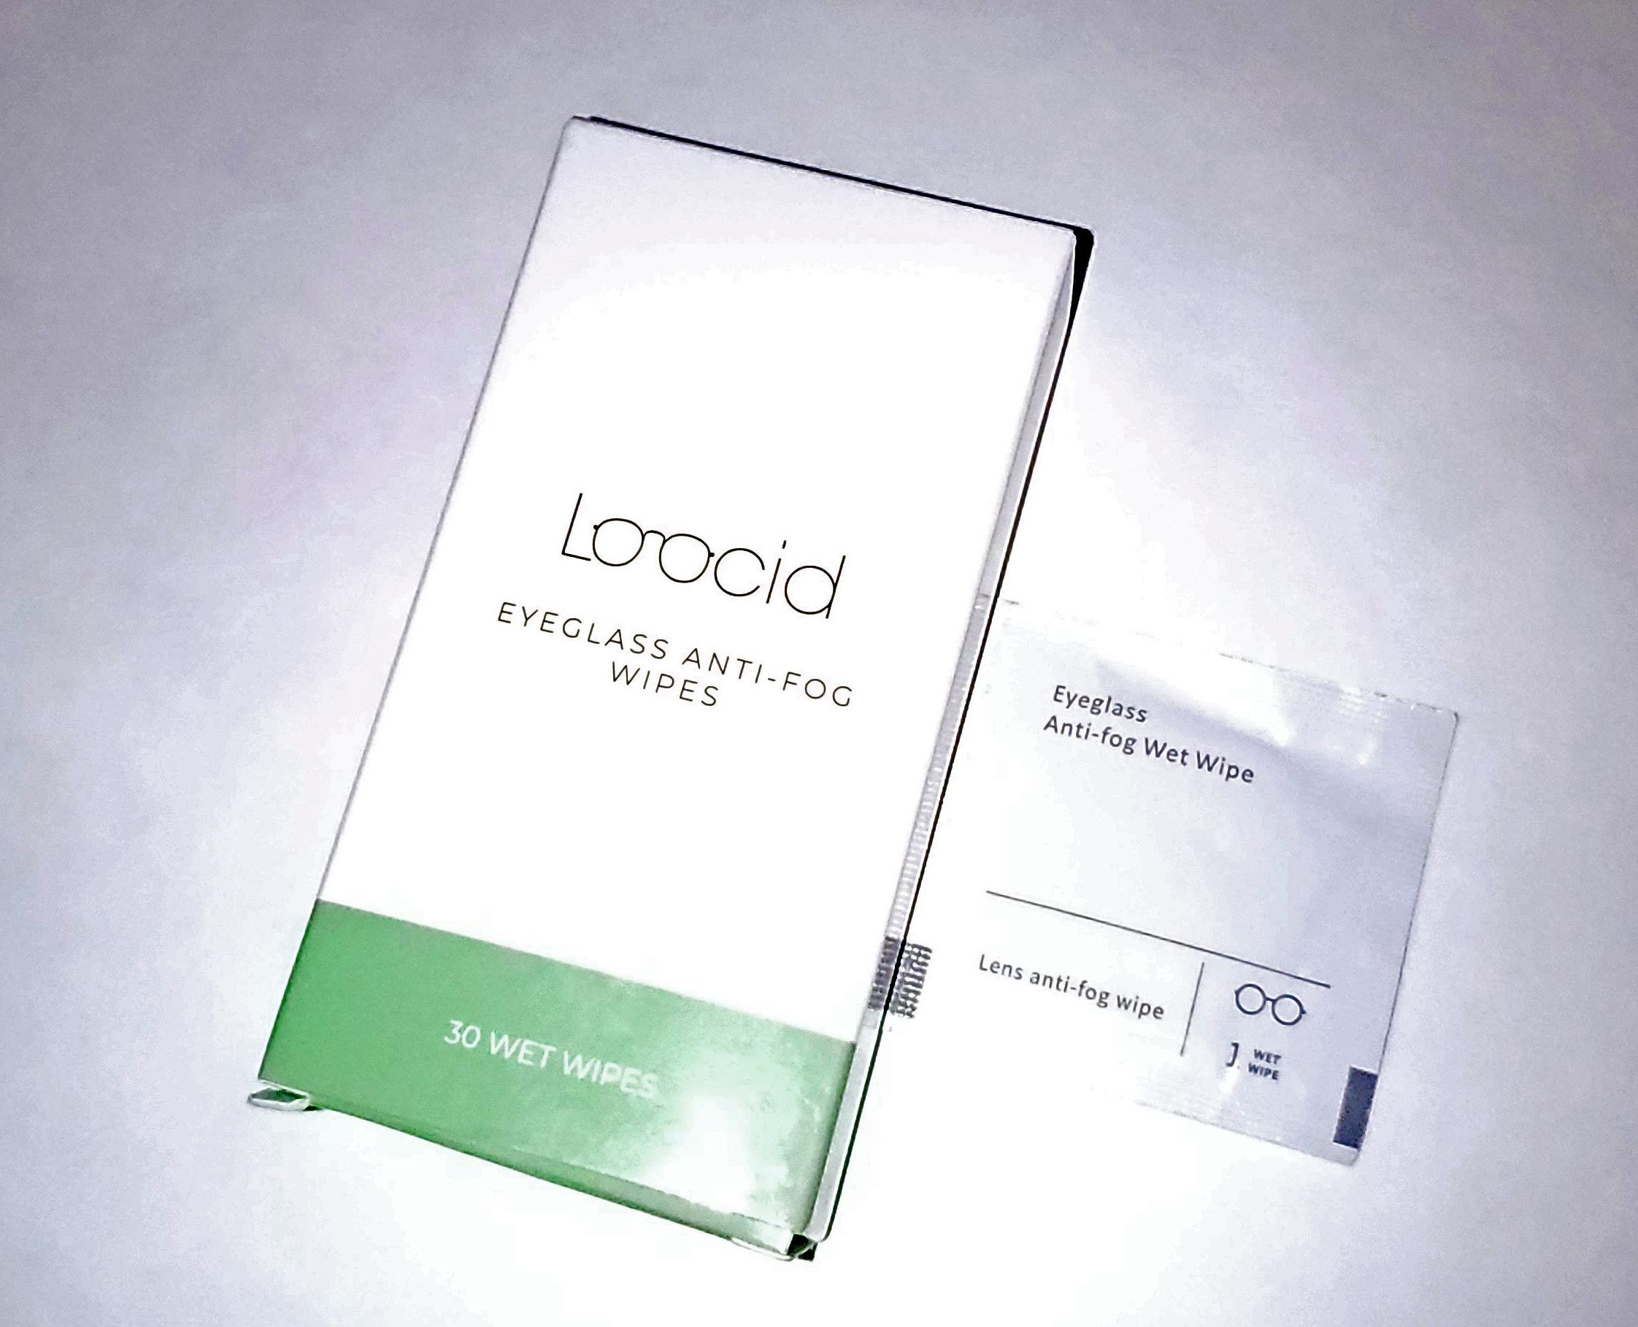Illustration 1

I found myself in the parking lot of a grocery store recently. I realized I had not applied RainX at home. So I pulled out a Loocid wipe packet, opened it, and got out the wipe. I wiped the inside of both lenses of my glasses, put on the PPE mask, and got out of the car.

The glasses fogged up immediately, before I was fully out of the car, possibly due to winter temperature in the parking lot. So I grabbed the same wipe and used the opposite side of the wipe to wipe the inside of my glasses again.

After that generous treatment, my glasses were fog-free not only for 20 minutes at that grocery store but also for another 30 minutes in another grocery store after roughly 15 minutes of car travel sans mask between the two stores.

The advantage of packets is that The Transportation Security Administration (TSA) will allow those to be carried by passengers.

I have been using Zeiss brand lens cleaner wipes to clean my camera lenses since late December 2019, because TSA will not let me carry my little bottle of lens cleaner fluid aboard an aircraft. I believe TSA would also object to a bottle of RainX.

TSA let me carry the Zeiss packets aboard when I last traveled by air in December, January, and February 2020. Therefore, I believe that TSA allows Loocid packets to be carried also.

If you travel by air during the pandemic, add up the time to be spent in airports, plus the flight time. You want your glasses to be fog-free for hours. Even if the initial treatment wears off, you can re-apply it when needed.

My only caveat about the Loocid packet is to apply each packet generously. Scrub scrub scrub.

I have an update on RainX. The company seems to have discontinued the smallest size of their interior glass anti-fog product. However, the next larger size of the product is still available, and on Amazon costs less per ounce of fluid than the smallest size.
ABOUT THE AUTHOR: John Krout has been writing about uses of personal computer tech since the early 1980s. He is a frequent contributor to PATACS Posts, the newsletter of the Potomac Area Technology and Computer Society, and occasionally provides demos on various tech topics at PATACS meetings. He lives in Arlington Virginia with his son, many computers and cameras, and too many cats.

